**Day 4 - Building Dynamic Frontend Components for Sofa Marketplace**

**This document offers a detailed analysis of the core functionalities of a dynamic marketplace, focusing on modularity, reusability, and seamless integration with Sanity CMS. Each feature is thoroughly explained, culminating in a conclusion that summarizes the overall approach.**

**Step 1: Overview of Core Functionalities**

The project incorporates the following essential features to create a responsive, scalable, and efficient marketplace:

**1. Product Listing Page**

**2. Dynamic Routing**

**3. Shopping Cart Functionality**

**4. Filter Method**

**5. Secure Checkout Process**

**6. Advanced Price Calculation**

**7. Product Comparison Tool Each feature plays a critical role in delivering a seamless and user-friendly experience.**

**Step 2: Detailed Functionalities**

1. Product Listing Interface The Product Listing Interface serves as the main gateway for users to explore available products. Leveraging dynamic data fetched from Sanity CMS, products are presented in a structured, visually engaging format, with options to display them in grid or list layouts for optimal usability.

**My Products From Api **

**Code of Its**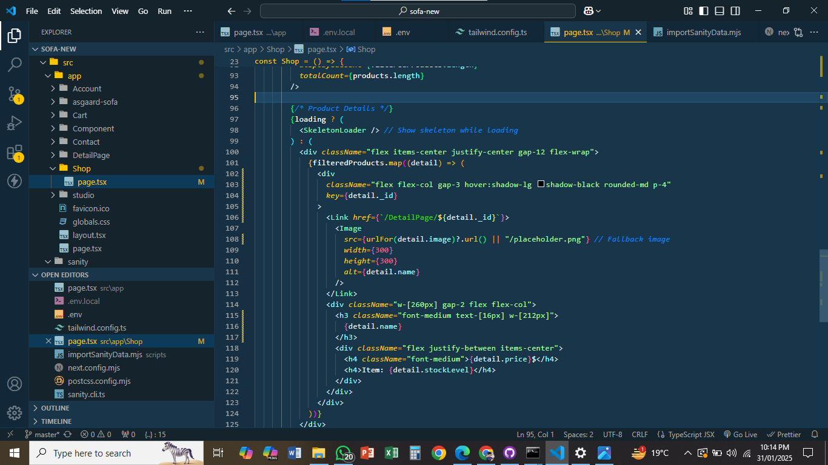

**Detailed Functionality Description**

**1. Product Listing Page**

**Advanced Sorting and Filtering:**

Provides enhanced usability by allowing users to sort and filter products based on attributes such as price, categories, and popularity.

**Efficient Pagination:**

Ensures smooth navigation and optimal performance when handling large datasets, enhancing user experience.

**Responsive Design:**

Guarantees seamless compatibility across a range of devices, from desktops to mobile phones, ensuring a consistent user experience.

**Real-Time Integration with Sanity CMS:**

Enables instant synchronization of product updates from the backend, ensuring the displayed data is always current.

**2. Dynamic Routing**

Dynamic routing facilitates the generation of dedicated product detail pages, offering users comprehensive information about individual products in a structured and user-friendly format.

**Products Detail 1  
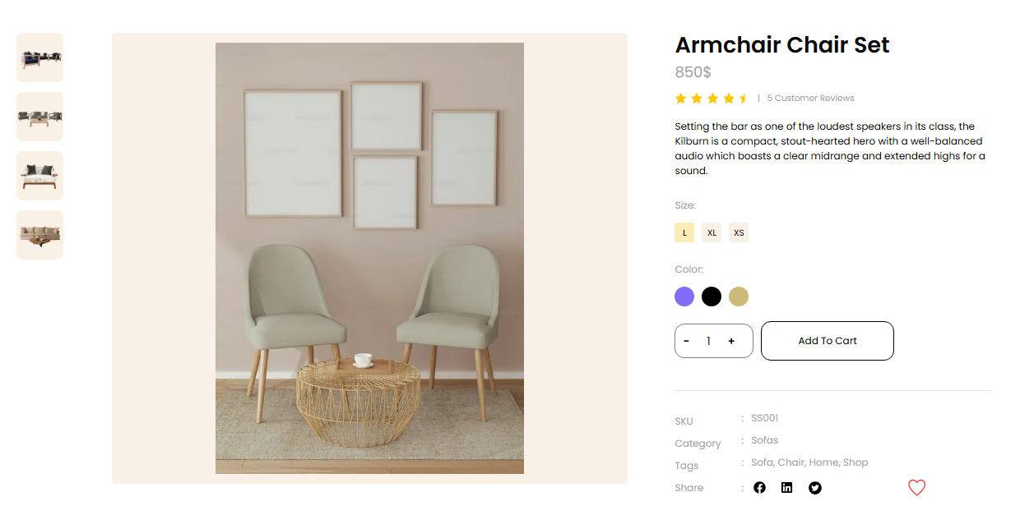**

**Product Detail 2**

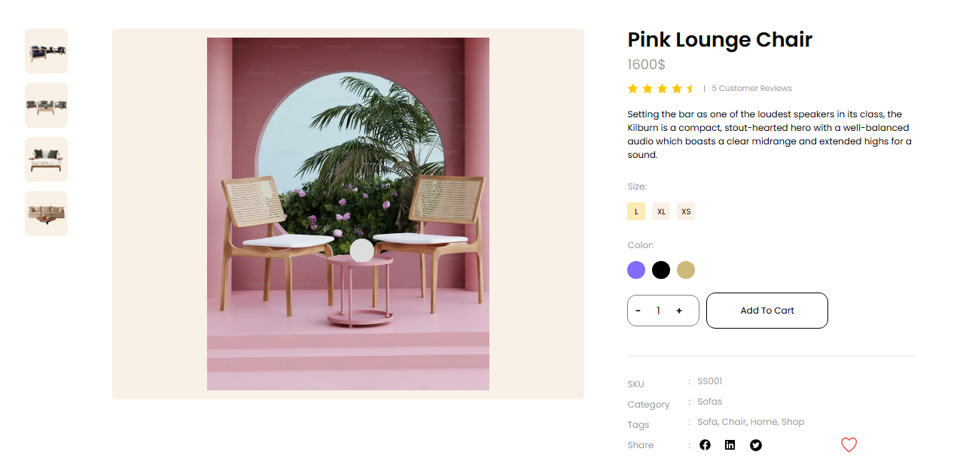

**Product Detail 3  
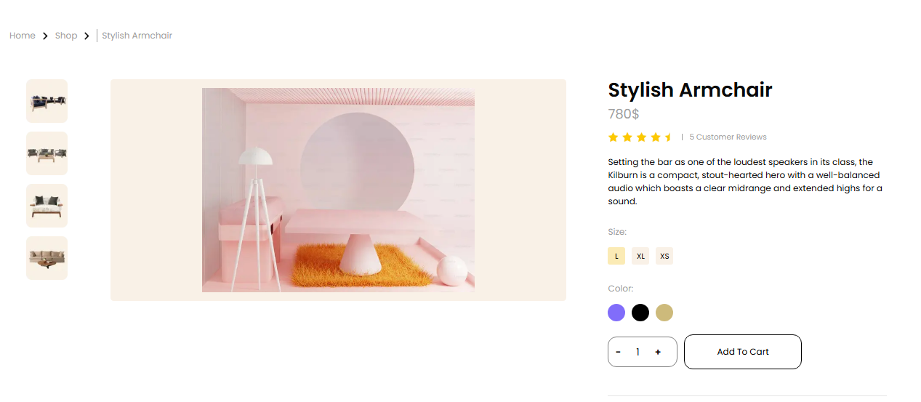 Code of Product Detail**

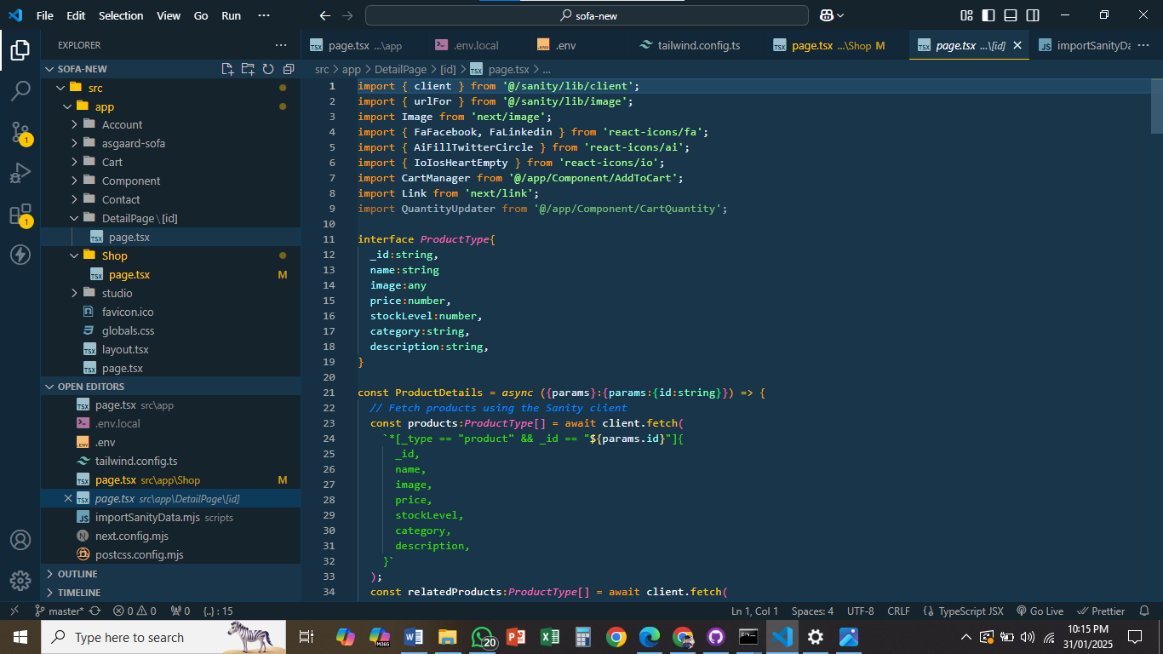

**Product Pages with Dynamic Routing**

**1. Each product is uniquely identified by an ID or slug, which is used to dynamically generate its dedicated URL (e.g., /product/[id]).**

**2. These pages are server-rendered to optimize SEO and ensure faster initial load times, improving the overall user experience.**

**3. Dynamic routing enables the seamless display of essential product information, such as descriptions, images, pricing, stock availability, and customer reviews.**

**4. This scalable solution allows new products to be automatically assigned corresponding pages, eliminating the need for manual updates.**

**Seamless Cart Functionality**

**The cart functionality is designed to streamline the shopping experience by managing and tracking the user's selected items.**

**1. The cart functionality is designed to streamline the shopping experience by managing and tracking the user's selected items.**

**2. It efficiently handles item selection, calculates the total cost, and provides a clear summary of the user's choices, ensuring a smooth checkout process.**

**3. This feature enhances user satisfaction by providing real-time updates on product selections and overall costs.**

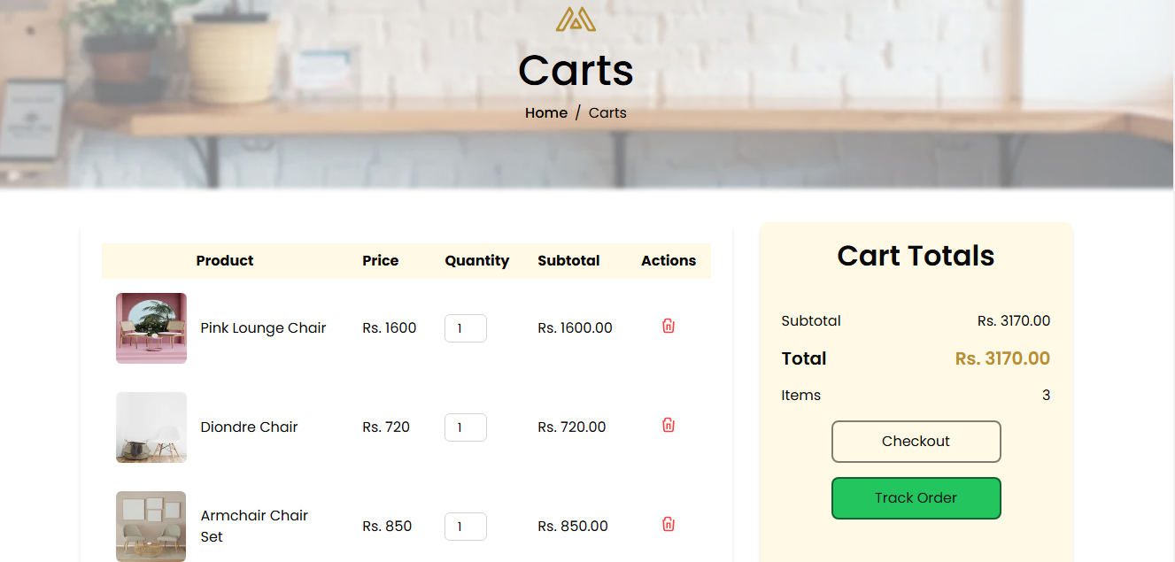

**Checkout Process**

**1. The checkout process is streamlined into multiple clear steps: Billing Details and Payment Information, ensuring an organized and efficient user experience.**

**2. A Dynamic Progress Tracker visually indicates the user's current step, helping users stay informed throughout the process.**

**3. Input Validation is integrated at each step to ensure that all required fields are filled correctly, minimizing the risk of errors during order submission.**

**4. While payment integration can initially be simulated, the checkout system is designed to be extensible, supporting payment gateways such as Stripe or PayPal for secure transactions.**

**5. At the final stage, Order Summaries are displayed, allowing users to review and confirm their order details before proceeding with the Place Order step, ensuring accuracy before finalizing the purchase.**

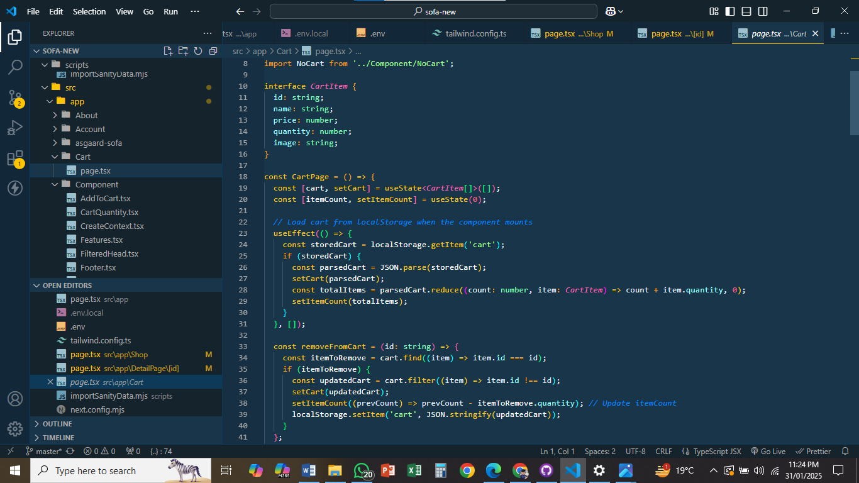

**Cart Functionality Breakdown**

**Remove Product from Cart**

Deletes a product using its unique id and syncs the changes with the cart state and localStorage.

**Empty the Cart**

Clears all products, resets the cart state, and removes cart data from localStorage.

**Adjust Product Quantity**

Updates the quantity of a product with validation to prevent invalid values (e.g., negative or zero) while reflecting changes in the cart state and localStorage.

**Filter Method**

**You can filter the products on the basis of categories Chair,Sofa,Tabes etc.**

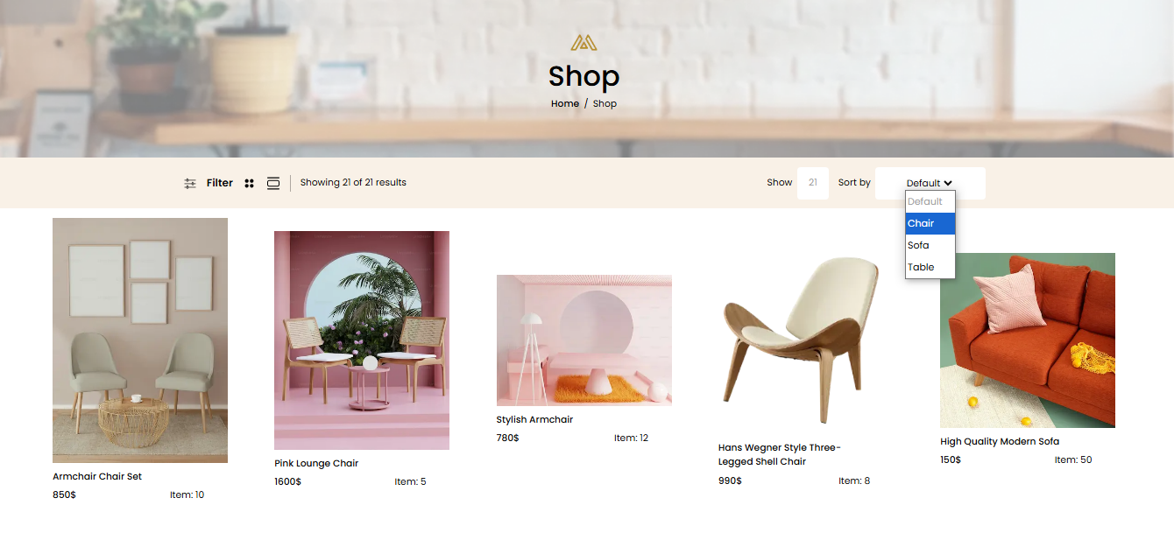

**Checkout**

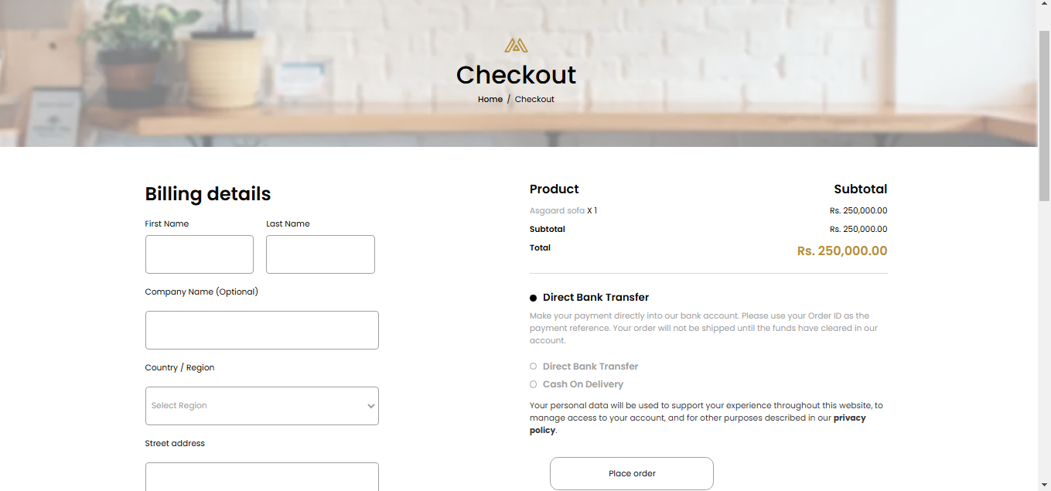

**Placing the Order**

**The "Place Order" feature marks the successful completion of the shopping journey by:**

**1. Review and Confirmation: Providing users with a detailed summary of their order, including item details, billing, and payment information, to ensure everything is accurate before proceeding.**

**2. Secure Order Submission: Sending the finalized order details to the backend for secure processing and storage.**

**3. Real-Time Acknowledgment: Displaying a success notification or redirecting to a confirmation page to reassure users that their order has been placed successfully.**

**Connecting with Sanity CMS**

**Sanity CMS acts as the backend, enabling dynamic management and retrieval of product data.**

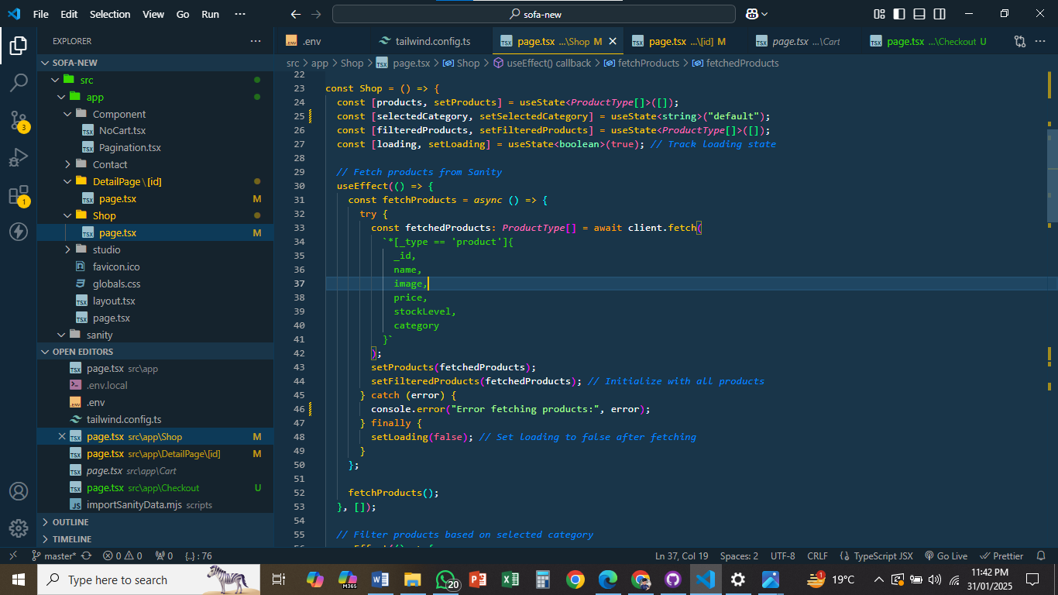

**Comprehensive Overview:**

**1. Sanity CMS stores products, categories, and metadata, empowering admins to update content without modifying the codebase.**

**2. A powerful client efficiently queries Sanity CMS, ensuring dynamic and reliable data fetching.**

**3. Real-time updates in the CMS are instantly reflected on the frontend, delivering a seamless content management experience.**

**4. The integration is highly scalable, allowing for the effortless addition of new data types or fields as the marketplace evolves.**

**Final Thoughts**

**Refined Summary:**

**This guide presents an in-depth strategy for creating dynamic, responsive marketplace components. With Sanity CMS managing the backend and employing modular frontend development practices, the application ensures scalability, performance, and an exceptional user experience. Every feature—from product listings to dynamic content updates—contributes to building a professional marketplace tailored to real-world demands. Future upgrades, such as advanced analytics or AI-driven recommendations, hold the potential to further enhance the platform's capabilities.**